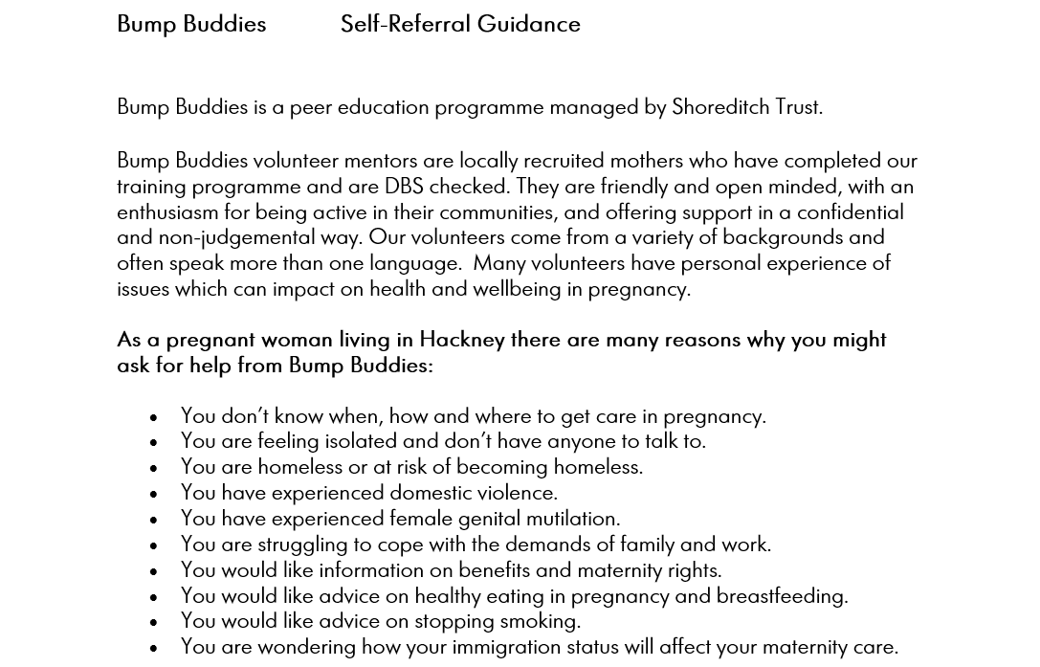
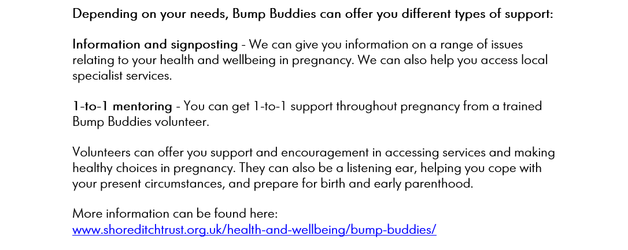

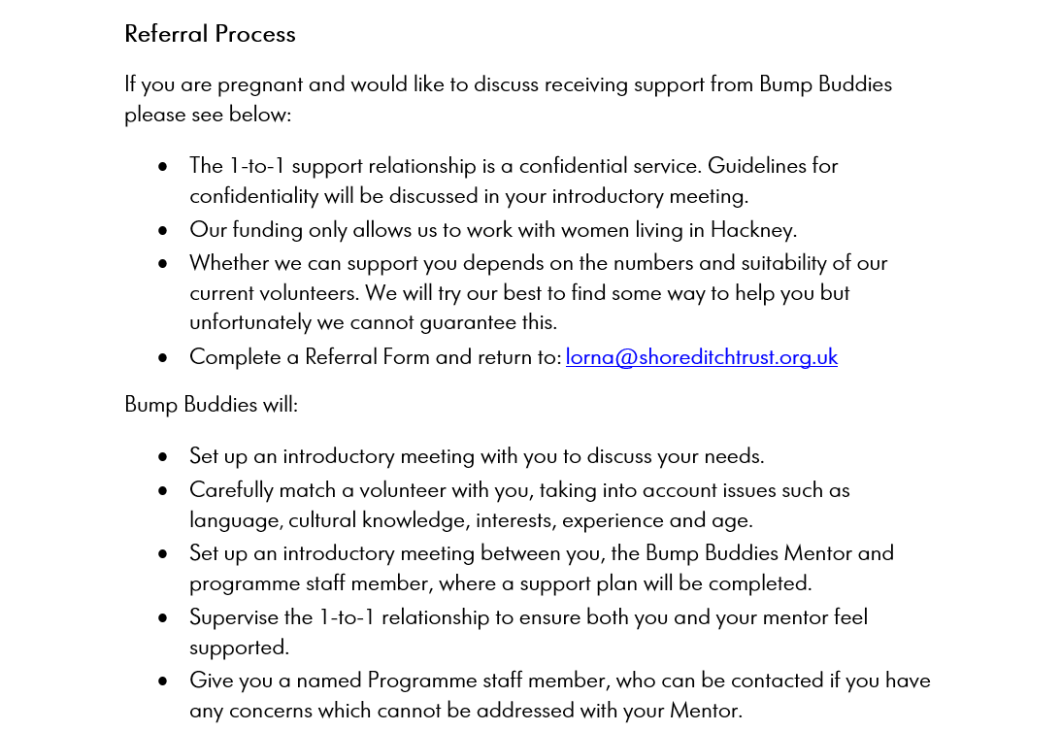
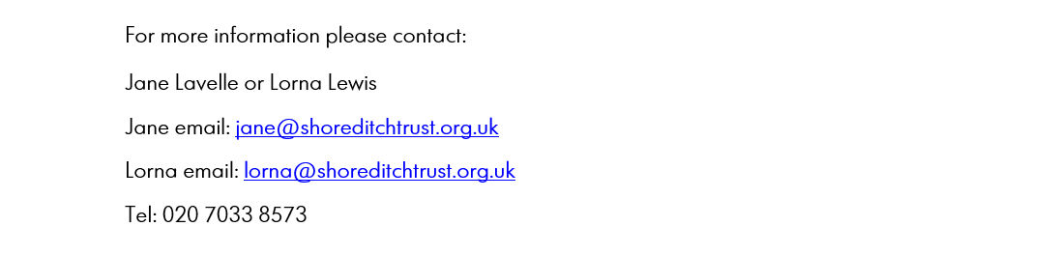

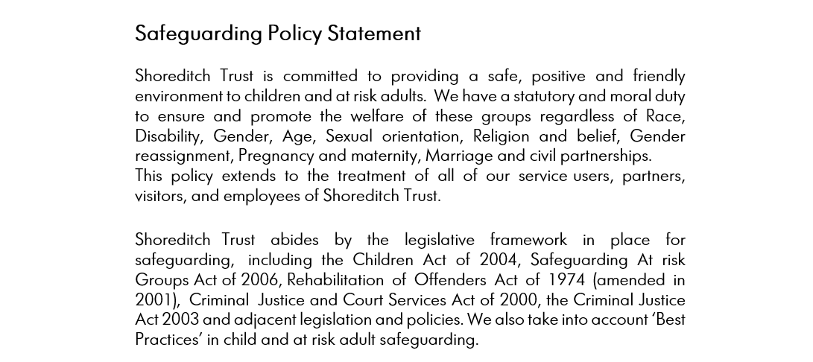

Your Details:
Name:
Date of Birth:
Postal Address:

Postcode:
Telephone:
Mobile:
Email:
Your preferred language if not English:
Please indicate your preferred mode of contact (please circle): | Phone Email Text
Your pregnancy:
Due date:
Named Midwife:
Booking Hospital:
Are you currently accessing other supportive services, e.g. Family Support?
- Service:
- Service:
- Service:
