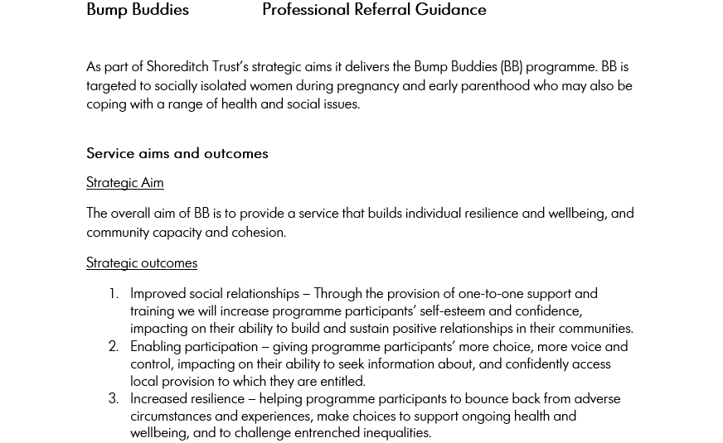
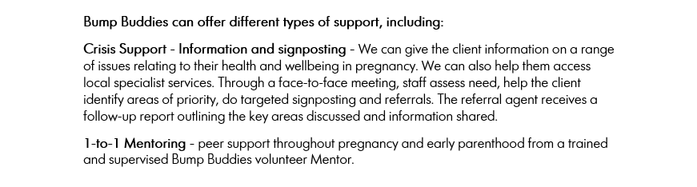

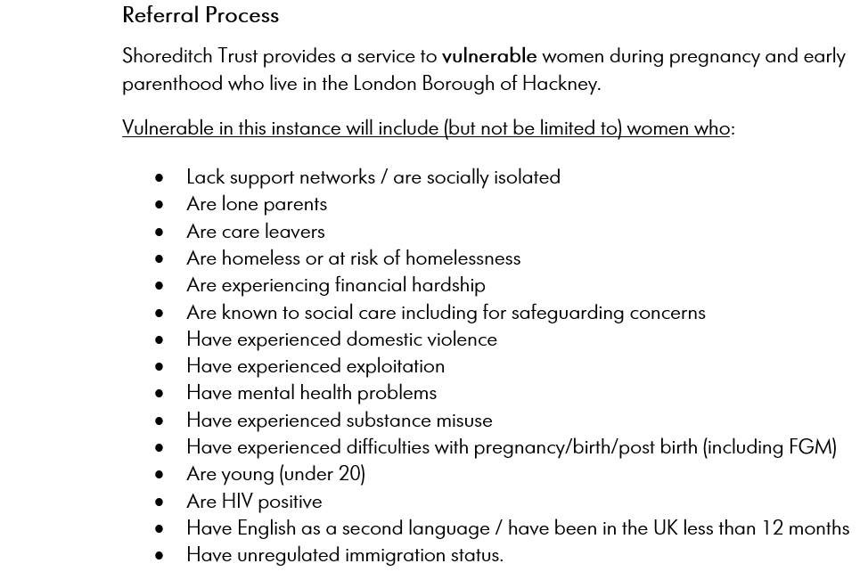
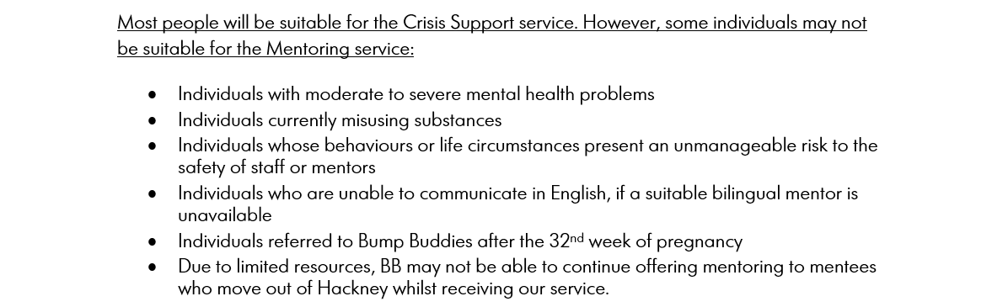
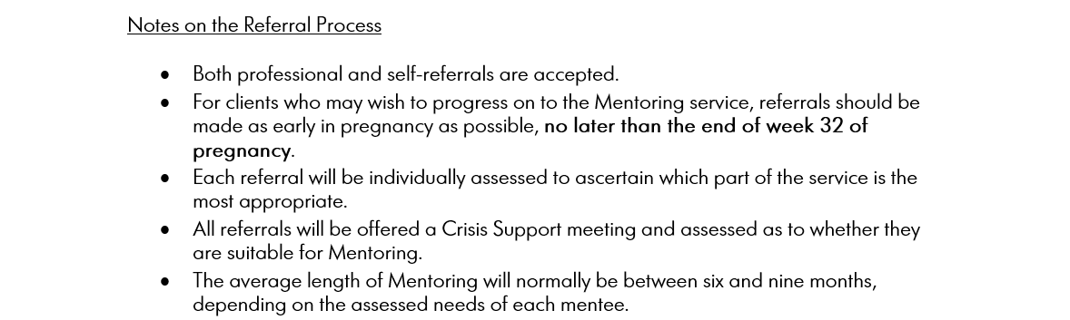

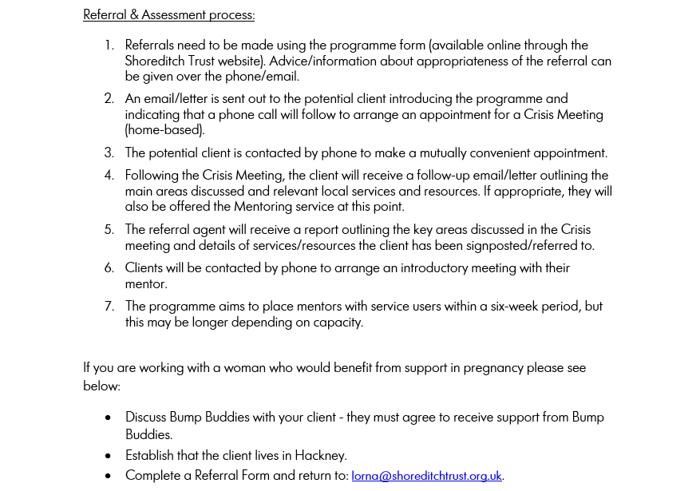

For more information please contact:

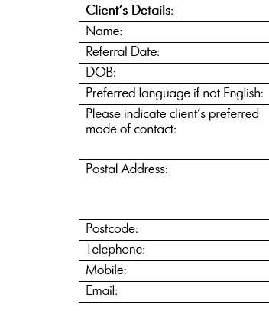
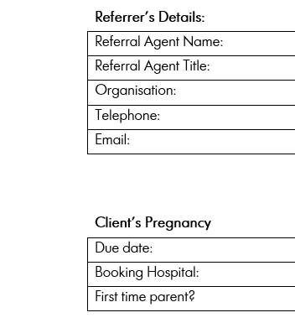

Client’s Details:
Name:
Referral Date:
DOB:
Preferred language if not English:
Please indicate client’s preferred mode of contact:

Postal Address:

Postcode:
Telephone:
Mobile:
Email:
Referrer’s Details:
Referral Agent Name:
Referral Agent Title:
Organisation:
Telephone:
Email:
Client’s Pregnancy
Due date:
Booking Hospital:
First time parent?

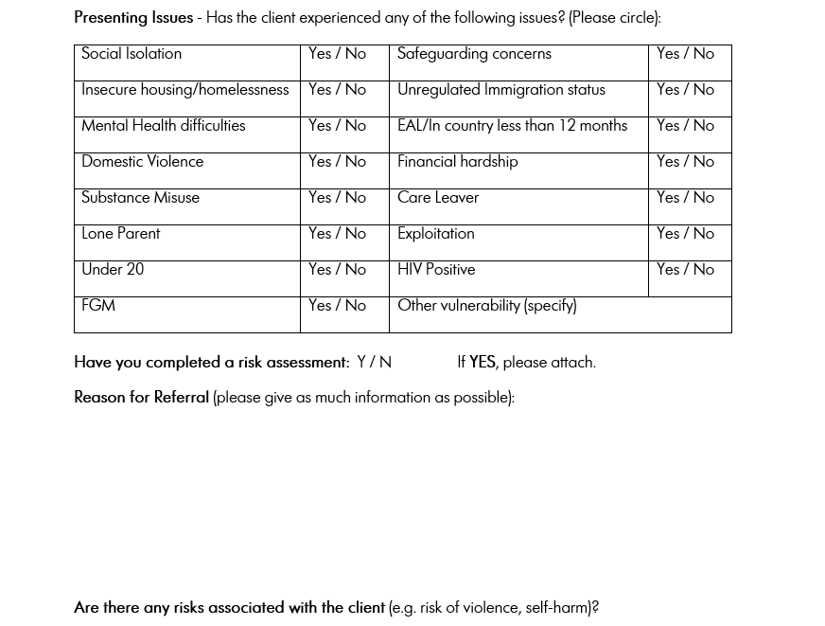

Ij][ojfyuk,dtt6yjisrj56

